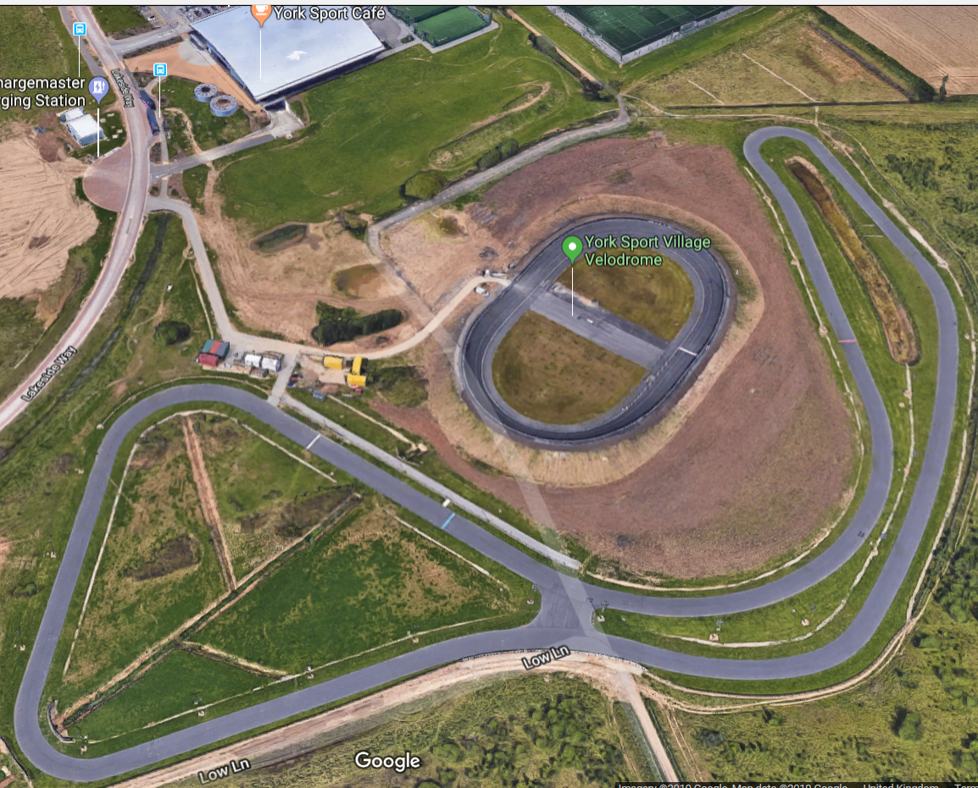
York Kids Triathlon – Event Arena
Pool entrance
Information
- Go to our (www.uktriathlon.co.uk) website to see how many lengths of the swim, laps of the bike and run course your children will need to do to complete their triathlon.
- The bike course is flat as well as on a very good tarmac surface.
- The run course is flat as well as on grass.
- Make sure your read your children’s event day information for a comprehensive outlook about the Kids Fun Triathlon.
- Distances will be made clear for the children on the day of the event via their event brief.
- There will be signs around the course and marshals guiding them in the right direction.
- If you're not sure about anything on the day, ask any member of the race crew around the course and at registration.
- The course may be changed by the organiser on the day of the event, depending on the weather conditions.
- No parents will be allowed pool side, this is for the safety of all the children. There is a viewing area within the leisure centre if you want to watch your child swim.

Bike start & bike finish
Bike mount & dismount line
Pool exit
Registration & on the day Event Information
Key Areas
Swim
Bike
Run
Run Course Turn Point
Cycle Transition Area
Finish Line

